Scope of work for Dilution refrigerator system. Contact Jennifer Fichtner with questions [jsfpur@rit.edu](mailto:jsfpur@rit.edu)

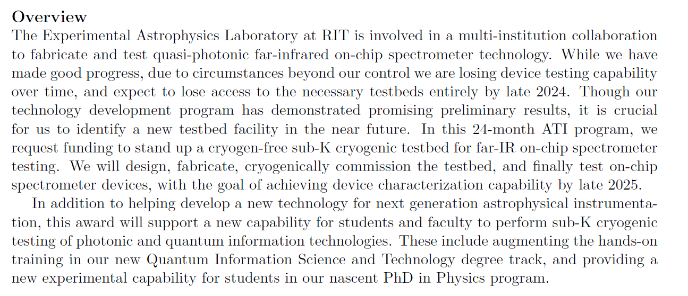

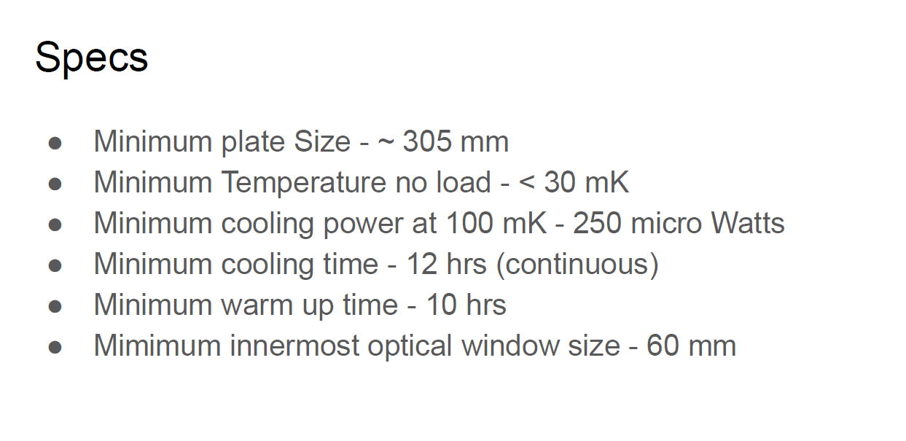

Please submit proposal to [jsfpur@rit.edu](mailto:jsfpur@rit.edu) no later than 10am 10/25/24. Proposal should include equipment, installation, training and all cost-listed separately. Include terms and conditions.